PSATHARIS AUCTION HOUSE

RESULTS – The 30th AUCTION

The 30th auction of the Psatharis Auction House was marked by an unprecedented high sale for the painting On the Loom by Cypriot naïf Michael Kashalos

PRESS RELEASE – AUCTION RESULTS

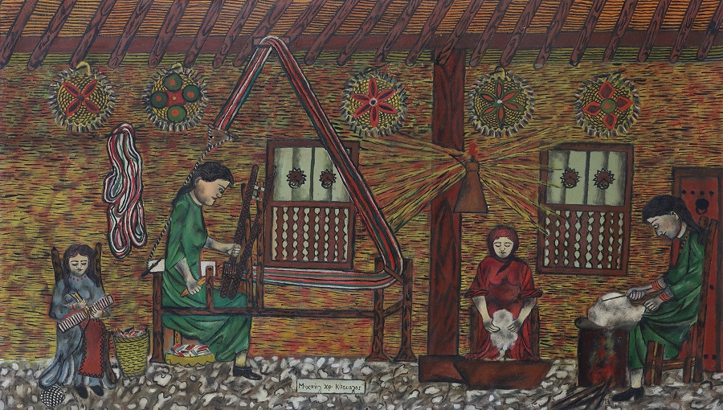

On the Loom, Michael Kashalos

NICOSIA, FRIDAY 10 DECEMBER, 2021 – The evening came alive amidst bidding for the painting On the Loom by Michael Kashalos, which set an unprecedented record for a high sale by the Cypriot naïf at auction. After ten bids the painting leapt past its estimate of €24.000 and sold for €48.246 becoming the highest-priced lot of the evening. Overall the evening auction of the 1st of December 2021 had great results.
The 30th Psatharis Auction was held at the Cleopatra Hotel in Nicosia. The auction took in a total of €€340.000. Of the 144 lots offered, the sale saw a sell through rate of 59 percent by lot (85 artworks sold) and 97 percent by value. On the Loom by Michael Kashalos was an incredibly bright moment setting a new auction price record for the artist. There was intense bidding for a lot of paintings many of which doubled their expectations.
Queen Caterina Cornaro and her Sister Cornelia, a masterful double portrait by an unknown apprentice at one of the Great Masters’ Studios of Renaissance Venice, was sold within estimates for the price of €28.284 euro.
Expectation by Alecos Fassianos sold within its estimates achieving €16 748 followed by A Peasant Woman rests next to the Haystack by Greek Theodore Ralli which fetched €16 499.
Huts in the Village by Yiannis Spyropoulos sold close to the highest bidder for €11.365. The painting carried an estimate of €7.500. Composition by Alecos Kontopoulos sold within estimates for €8.972. The Young Drinker by Pericles Pantazis also sold within expectations fetching the amount of €8 838.
The Folio of 12 Etchings of the Principal Views & Places of Interest in Cyprus, a rare edition by Tristram James Ellis sold for the price of €11.141.
Intense bidding
Spenders bid intensely against each other for Tohni by Fotos Hatzhisoteriou, which after eight bids leapt past its estimate of €3.500 selling for €8.374 as well as for Pernera-Paralimni by Lefteris Economou which leapt nine bids to fetch €6.579.
Blooming Almond Tree in Evrychou by Ioannis Kissonergis and Flowers in the Vase by Solomos Frangoulides sold within their estimates for the price of €4.952 and €4.785 respectively. Figure by Dimitris Mytaras also sold within expectations for €5.981.
After nine bids Archaic in Black and Orange by Stelios Votsis sold for €5.981. The painting which was exhibited at the 1968 Venice Biennial carried an estimate of €3.000.
Mother and Child by John Corbidge and Sailboat by Petros Katsas, each 13 bids, were sold for €2.511 and €2.392 respectively. Landscape, a gouache by Christoforos Savva was sold to the highest bidder for €5.263. After six bids, Landscape nearly doubled its estimate of €3.200.
Black Animal leapt nine bids to achieve the price of €4.785. The artwork carried an estimate of €2.000. Girl with Pitcher, a woodcut on rice paper dating back to 1941, by Telemahos Kanthos also leapt nine bids past its original estimate of €900 to fetch the price of €2.033.
The results include Sale Prices and can be viewed at: www.psatharis-auctions.com.cy

