PSATHARIS AUCTION HOUSE


The Twenty - Fifth Auction of Greek and Cypriot Art Works

Wednesday, 5th of December 2018, 7:00 p.m.

HILTON Hotel, Nicosia

PRESS RELEASE
Adamantios Diamantis, The Secret
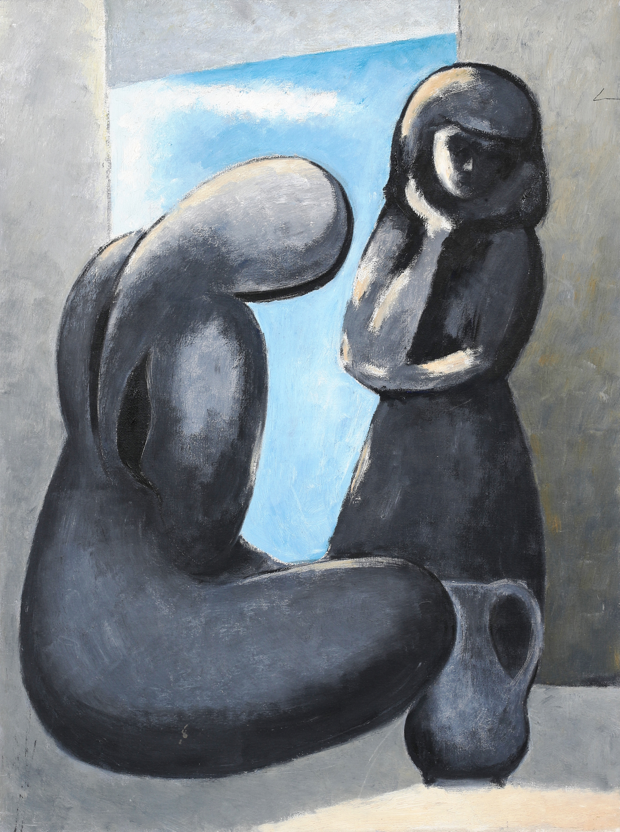
VIEWING
HILTON HOTEL, Nicosia: 3 - 5 December. 2018
The Secret is an exquisite painting by emblematic Cypriot artist Adamantios Diamantis and will be offered at auction on the evening of the 5th of December at the Hilton Hotel in Nicosia. The 25th Psatharis Auction will feature a total of 117 artworks by Greek and Cypriot artists whose work has shaped and influenced the contemporary Greek and Cypriot art. A preview of the collection will be held from December 3 - 5 at the Hilton, in Nicosia.
'The entire collection of works, stretching from the Secret by Adamantios Diamantis to the Weight Lifter by great colourist Glyn Hughes is a visual guide to the evolution of the Greek and Cypriot art of the 20th century', says Nikos Psatharis, founder of the Psatharis House.
Paintings given the highest pre-sale prices include the Secret (€23.000 – 28.000) by Adamantios Diamantis, the Life Line (€19.000 – 25.000) by prominent modernist Christoforos Savva, the Woman pulling yarn and Woman in the wardrobe (€16.000 – 21.000) by Michael Kashalos and Sofia Kyrillou and goats (€10.000 – 15.000) by landscapist Tilemahos Kanthos.
Steady growth in prices and a renewed interest from Greek and Cypriot investors at home and abroad has led to many paintings, which had been in private hands for decades, finding their way back to the art market," notes Nikos Psatharis.
Fine Art Investment
Works expected to command top interest include the following: Flautists by Andreas Charalambides (€8.000 - 11.000), Birth of an Angel (€6.000 - 9.000) by Christos Christou, Nude by Christos Foukaras (€4.500 - 6.000), Sailing vessel by Emilios Prosalentis (€2.500 - 3.000), Landscape by Solomos Frangoulides (€5.000 - 7.000), Sleep by Polykleitos Rengos (€2.800 - 3.500), Young Women by Stass Paraskos (€2.500 - 3.500), a painting from the series "Stones and Water" (€7.500 - 11.000) by Andreas Ladommatos, Boat and flowers by Spyros Vasiliou (€4.500 - 6.000), The Couple by Yannis Gaitis (€4.700 - 7.000), Village in Limasol by Viktor Ioannides (€4.700 - 7.000), Without Title by Georgios Derpapas (€5.500 - 8.000), Landscape by Giorgos Gounaropoulos (€4.500 - 6.000), Figure by Dimitris Mytaras, Butterfly by Dimitris Yeros (€2.000 - 3.000), Portrait by Elli Mitzi (€2.000 - 3.000), a painting from the series "Streets of Old Nicosia" (€3.000 - 5.000) by Lefteris Economou, Without Title by John Corbidge (€2.800 - 5.000), St Charalambos - Myconos 1941 by Nikolaos Othonaios (€2.000 - 3.000) and Without Title by Stelios Votsis (€2.500 - 3.000) and many others.
LOTS
Adamantios Diamantis The Secret (oil on canvas, 80 x 60 cm, €23.000 - 28.000)
First generation Cypriot landscapist and figurative painter Adamantios Diamantis (1900 - 1994 drew his inspiration from daily life, particularly rural life. His monumental painting The World of Cyprus capturing the essence of village life is regarded as one of the most recognizable works of contemporary Cypriot painting. The Secret, however, which goes to auction on the 5th of December marks a departure from traditional painting. In this unique painting, the artist sets to explore the geometricity of the form whilst experimenting with sculptural effects alluding to enduring themes within the art of Henry Moore.
Christoforos Savva Life Line (oil on canvas, 110 χ 60 cm, €19.000 - 25.000)
Christoforos Savva (1924 - 1968) has been one of the first painters to reinvent Cypriot Art introducing it to contemporary currents and modernist trends. His work carries influences of French Modernism, Fauvism, Cubism and Abstract Art. Life Line was exhibited for the first time in 1968 at the Goethe Institute in Nicosia. Art critic Costas Serezis offers rare insight into how modern art was perceived in that era when he writes that Savva had succeeded "to adding faithful admirers to the deniers of his work." Life Line, visibly influenced by Matisse, marks a liberating moment for the artist who is transcending form in order to explore pure colour.
Michael Kashalos Woman pulling yarn and Woman in the wardrobe (oil on hardboard, 55 x 856 cm, €16.000 - 21.000)
This is an exquisite piece of art by leading Cypriot naive artist Michael Kashalos (1885 - 1974). The artist projects his narration through circular forms and parallel lines creating movement in still space. His female figures, which lie in the foreground of the two-dimensional painting, are revealing of the artist's desire to depict motion and spontaneity. Kashalos succeeds in imbuing his flat space with movement thus creating a powerful composition.
Georgios Derpapas Without Title (oil on wood, 115 x 90 cm, €5.500 - 8.000)
Greek poet Odysseas Elytis described the works of Greek surrealist Georgios Derpapas (1937) as "realms outside of time." In keeping with the latter description, Without Title is a fascinating piece of art. Derpapas creates an unearthly world in which the byzantine motif which is characteristic of the artist's works, becomes an integral part of the bold composition.
Giorgos Gounaropoulos Landscape (oil on contra plaque, 45 x 65 cm, €4.500 - 6.000)
The Landscape captures the essential gesture of the form. Gesture is everywhere, transforming the composition into expression and movement. Greek painter Giorgos Gounaropoulos (1889 -1977) studied and lived in Paris. He exhibited at the Parisian Vavin-Respail gallery. He received the Guggenheim International Award.
Polikleitos Rengos Sleep (mixed technique on canvas, 60 x 100 cm €2.800 - 3.500)
In the Sleep, the sea and the sky entwine as one accentuating the immenseness of the nude female figure. There is a visible Picassian influence on the female form whilst artist's agile use of brushstrokes creates a sense of fluidity. Polykleitos Rengos (1903 -1984) is one of the exceptional Greek artists.
Inquiries:
Psatharis Auction House
Telephone numbers: 00357 24621109, 00357 99 564131
E-mail: psatharisauctions@cytanet.com.cy
The works can be viewed at: www.psatharis-auctions.com.cy

