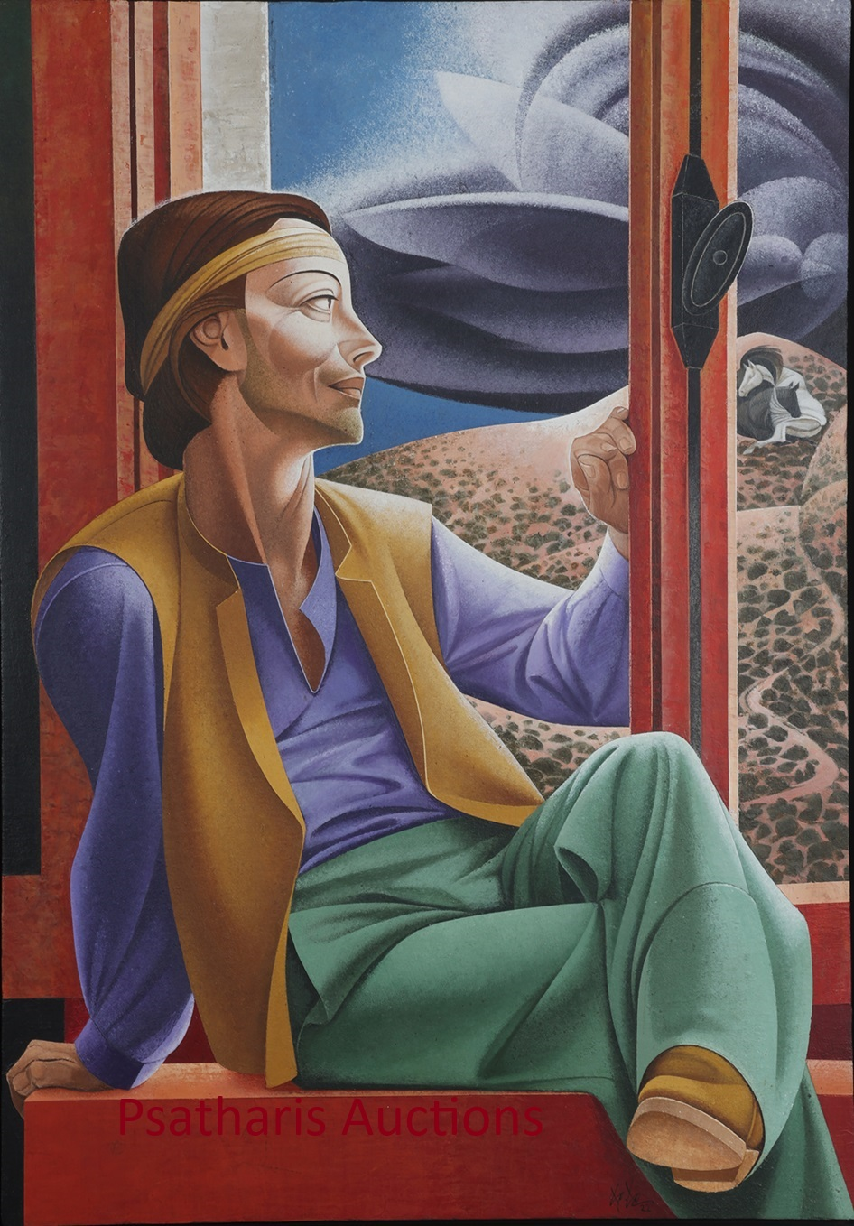**PSATHARIS AUCTIONS**



35th Auction Sale by Psatharis

WORKS BY CYPRIOT, GREEK AND INTERNATIONAL ARTISTS

29 May 2024 at 8 pm CLEOPATRA Hotel, Nicosia

**PREVIEW  
CLEOPATRA HOTEL, Nicosia MACEDONIA HALL  
Monday 27 May 10.00 a.m. - 9.00 p.m.  
Tuesday 28 May 10.00 a.m. - 9.00 p.m.  
Wednesday 29 May 10.00 a.m. - 5.00 p.m.**

Christos Christou, The window

Lot no.: 68

The Psatharis auction house is organizing the 35th auction of works by Cypriot and Hellenic Artists to be held in Nicosia, at the Cleopatra Hotel, on Wednesday, May 29. The 35th auction features a collection of 161 remarkable works that will enable the art-loving public to compete to acquire them.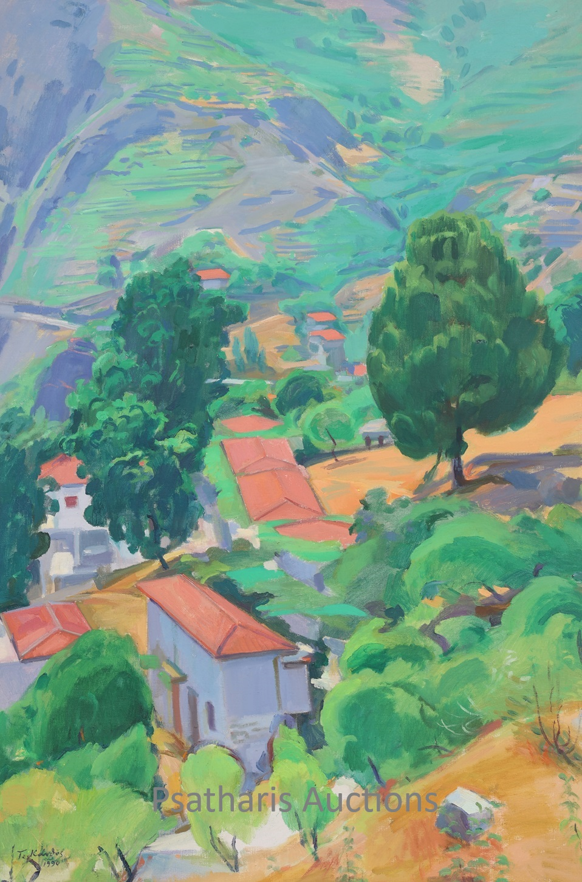

The catalog opens in an unusually impressive way. Number one presents a watercolor by Ioannis Kissonergis that presents the picturesque harbor of occupied Kyrenia with the special colors of the artist's palette. The work has large dimensions compared to other watercolors by the artist and has been published in the Kissonergis monograph. Immediately afterwards, a particularly fresh watercolor by Telemachus Kanthos is presented. It is entitled Varosi and presents the beach of the currently occupied city with roughly printed human figures and umbrellas coloring the landscape. This is followed by a watercolor by Polykleitos Regos that presents a Spanish landscape and then works by Emilios Prosalentis, Paris Prekas, Angelos Giallinas, Spyridon Skarvelis as well as a landscape watercolor by Adamantios Diamantis and Kostas Oikonomos showing houses in occupied Akanthou..

Telemachos Kanthos,

Houses in Avrillis, the big pine tree, two oak trees in Gyrona. Lot no.: 33

Of the 6 beautiful works by Stelios Votsis presented in the catalogue, we note the monochrome, linear and untitled work at number 14 where the particularity of the artist's work is crystallized and at number 155 we also find a rare composition with palettes and colors.

After the beautiful Escape of Dimitris Geros, the catalog presents a rich collection of 9 still lifes. The first is the still life with chrysanthemums by Loukia Nikolaidou, a work published in the painter's monograph. Then follow two works by Lefteris Oikonomos and then works by Constantinos Byzantios, Apostolos Geralis, and Achillea Druga. The collection of still lifes ends with two works by Georgios Mavroidis. Number 33 is dominated by the Houses in Avrillis, The great pine tree, Two oaks in "Gyrona" by Telemachus Kanthos. The work presents the special palette of the Cypriot mountain landscape that the Cypriot artist so masterfully captured in his works. The thousand greens and blues, purples and blues of Kanthos are a sample of painting poetry and a harmonious impression of the landscape of his special homeland. Three more works by the same artist follow, Elia and the Warehouse, Hamospita and Aniogma in Kampos. The three works reflect the same color wisdom of the artist but also his ability to produce volumes through flat, almost, colors and through the games of shadow and light. Next are works by Polykleitos Regou, Lefteris Oikonomou 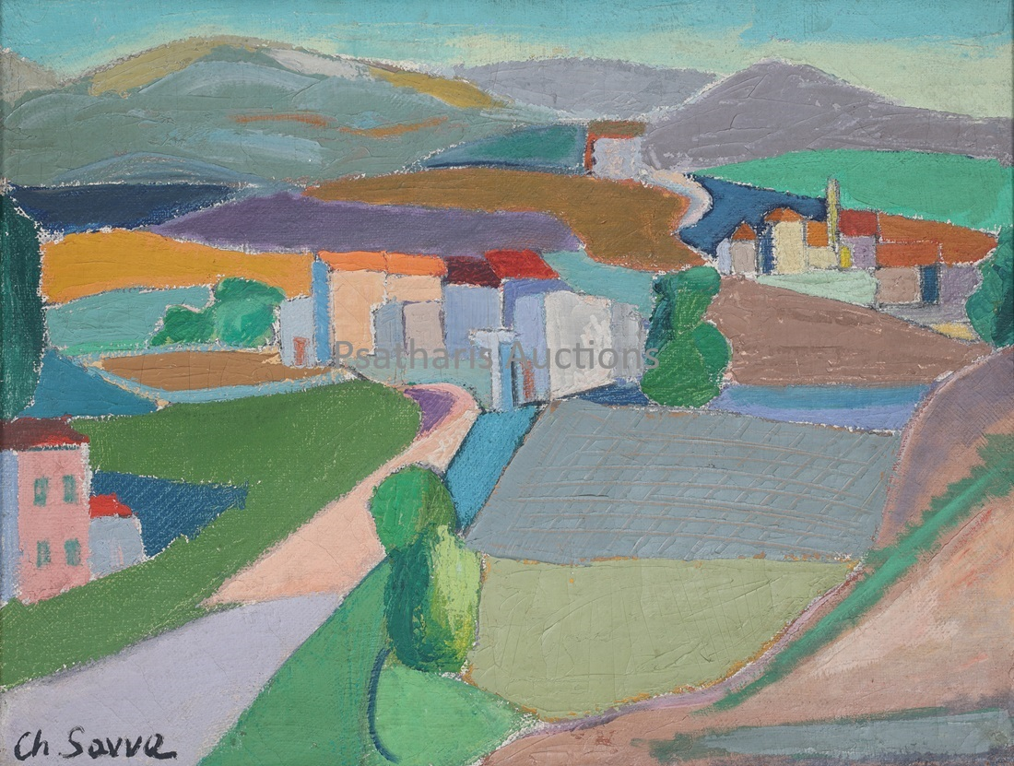and an oil and two pastels by Speranza.

*Christoforos Savva, Landscapes in the South of France,* Lot no.: 50

Apostolos Geralis' May Day gives the auction flow a touch of classical romance before the important works Spiros Vassiliou's Scarecrow and Christopher Savva's Landscape in the South of France. Works very different but equally intense through the modern and penetrating gaze of two artists who marked their time.

After the three works by Foinikarides that present the special world of the artist, two works by Andreas Ladomatos from the 1980s follow. They are White Daisies in Scorpio Stones and Pants with fruits, flowers and colors. Next, number 58 presents the work of Ioannis Kissonergis, Fishermen in occupied Karpasia. The work is an iconic image for the artist's output and is an example of a sensitive psychographic impression of the Cypriot coastal landscape of the Cypriot peninsula.

Three special works by Alekos Fasianos enrich the house's thirty-fifth auction. It is about the composition The People with the Cigarette, Figure and Mother of God. The first two works are from the 1960s and reflect a more post-expressionist mood, while the third work follows the Virgin Mary by Father Kallinikos Stavrovouniotis, the last known hagiographer of the long tradition of the Monastery. After the works of Christos Christos with their delicate aesthetics and the two works of 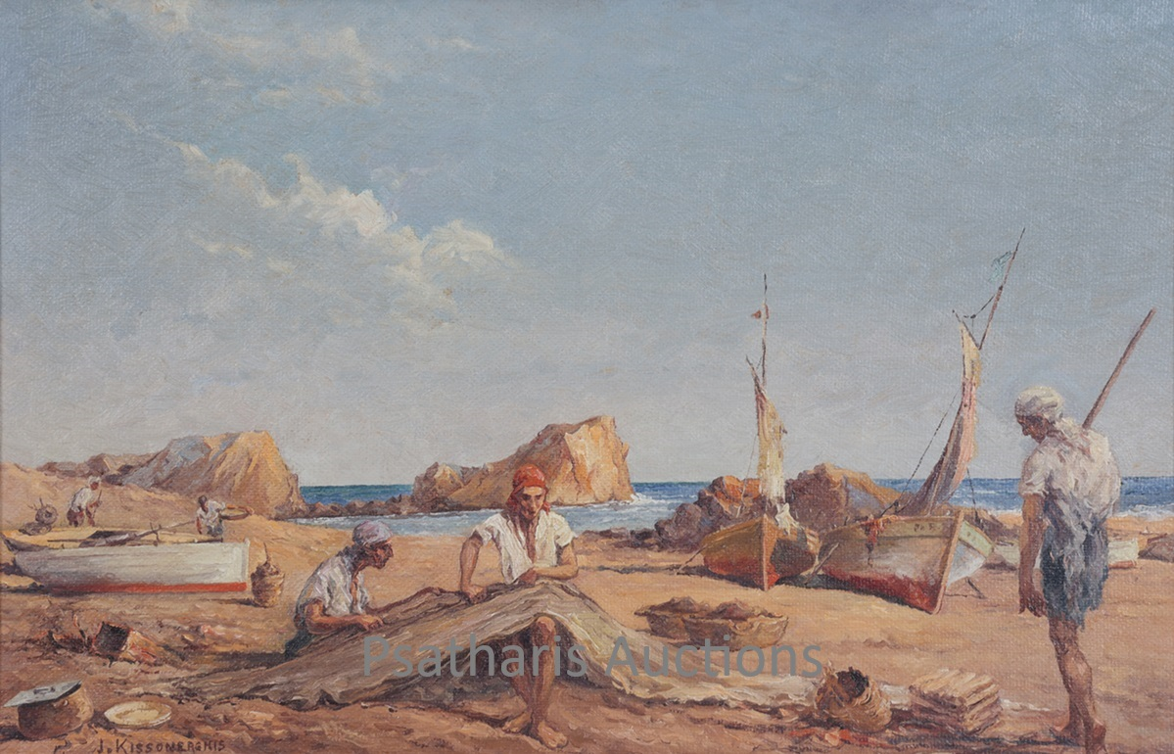Victor Ioannidis.

Ioannis Kissonergis, Fishermen in Karpasia. Lot no.: 58

*The Old Man Spins a Thread of Michael Chr. Kasialou, it would not be an exaggeration to say that the work of the best-known Cypriot folk painter constitutes a real jewel in the auction catalog, through its priestly structure and rich coloring. Two other works by the artist are presented in the catalog at numbers 150 and 151, both three-dimensional, a carved Cypriot head entitled Sleeping and a wooden miniature of a plow These works bear witness to Cassialos's inexhaustible creativity and the original immediacy he possessed in his expression.*

The list continues with works by, among many others, Giannikouris, Charilaos Dikaios, Photos Chatzisotirios, Kikos Lanitis, Pavlos Samios, Ilias Karseras, Stas Paraskou, Loizos Sergiou and Kaitis Stefanidou. Of the three works of Giorgos Skoteinos, Mikrokosmos - Makrokosmos of 1965 stands out. For their time and quality, the works of Nikolaos Othonaios, Atenizando, and Theofrastos Triantafyllidis, On Stavlos., Opy Zounis, Elenis Hariklidou, Giorgos Erotokritos, Yiannis Kotti stand out. , Giorgos Varlamos, Pavlos Dionysopoulos, Evgenios Spatharis, Andreas Charalambidis, Andreas Makariou, Loukas Geralis, Alexandros Alexandrakis, Andreas Karagian, Andros Efstathiou.

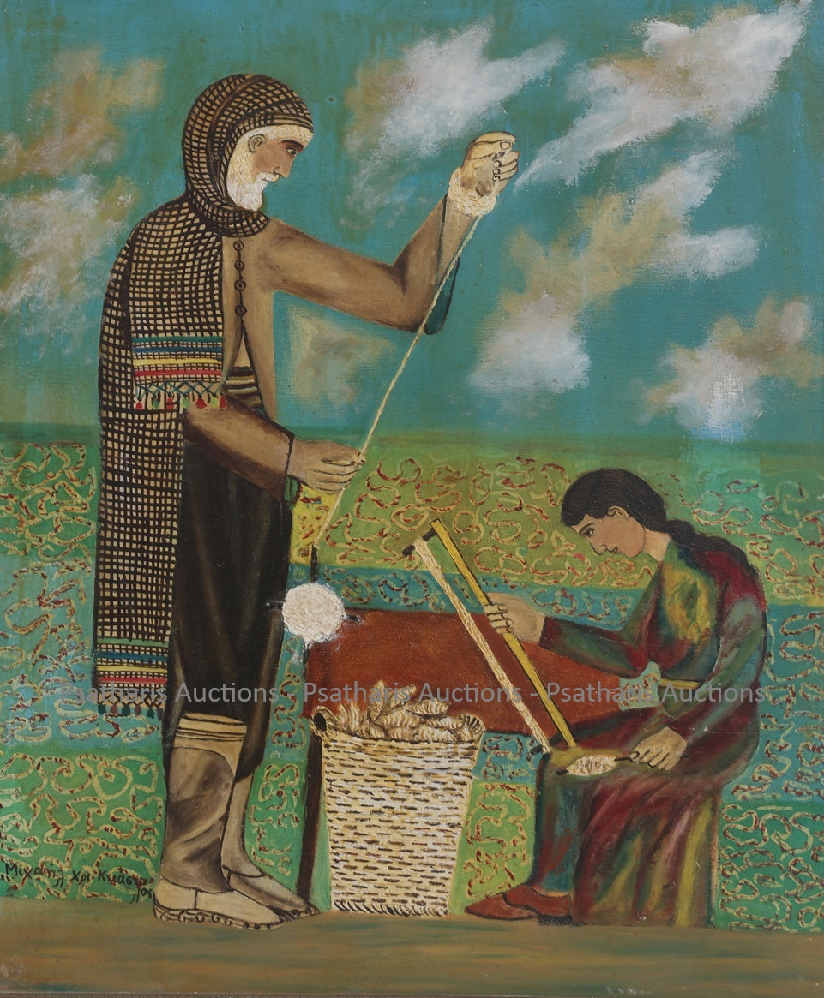An intense work by Andreas Chrysochos is presented at number 136 and is followed by two strong works by Pavlos Dionysopoulos and Marios Prasinos. Matter, Space, Time is the title of Nikos Kourousii's work which opens the three-dimensional constructions section, closes the 35th auction with 2 sculptures by Dimitris Constantinos and 7 by Yannis Moralis. respectively.

Ένα έντονο έργο του Ανδρέα Χρυσοχού παρουσιάζεται στον αριθμό 136 κι ακολουθείται από δύο δυνατά έργα των **Παύλου Διονυσόπουλου** και **Mάριου Πράσινου**.*Ύλη, Χώρος, Χρόνος* είναι ο τίτλος του έργου του **Νίκου Κουρούσιη** που ανοίγει την ενότητα των τρισδιάστατων κατασκευών, κλείνει την 35η δημοπρασία με 2 γλυπτά του **Δημήτρη Κωνσταντίνου** και 7 του **Γιάννη Μόραλη**. αντίστοιχα.

Michael Ch. Kashalos, The Old Man Spins a Thread, Lot no.: 72

General Information: Psatharis Auction House

Phones: 00357 99 564131, 00357 24621109   
E-mail: psatharisauctions@cytanet.com.cy

Websites: www.psatharis-auctions.com.cy and www.invaluable.com