Thirty-Second Auction of Cypriot and Greek Works of Art

28th – 30th November 2022, Cleopatra Hotel, Nicosia

PRESS RELEASE – AUCTION RESULTS
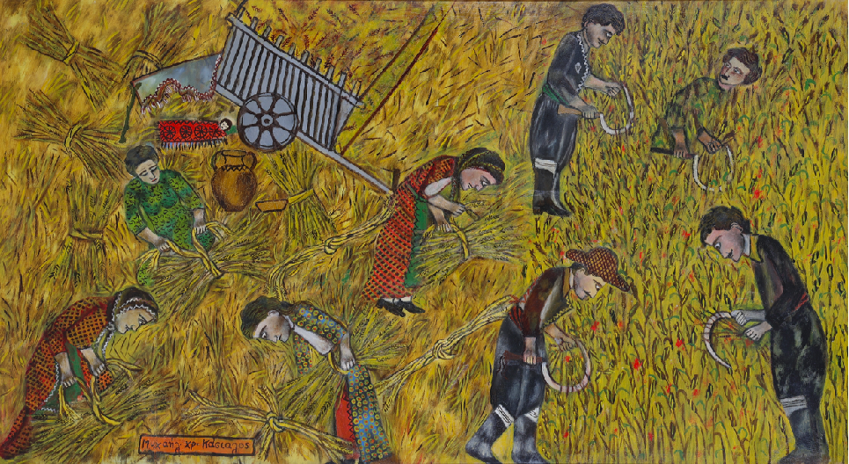
M. Ch. Kassialos, Theros (cat.n. 41)

In a warm and friendly environment, the thirty-second auction of Psatharis Auction House took place at the Kleopatras Hotel in Nicosia on November 30th. Collectors and connoisseurs had the opportunity to enjoy the rich collection exposed once again by the Auction House and then bid in the auction. The interest shown by collectors was commensurate with the quality and rarity of the works of art in relation to their affordable starting prices, then translated into sales of 58% of the lots in the catalogue.

Buyers were warmed-up with the art pieces on paper, watercolours and engravings that undoubtedly pleased with their quality and collectable value. Kanthos' emblematic woodcut entitled Lament of Women (estimated price 700 euros) raised particular interest. It reached the final value of 2,164 euros after 14 bids, while his work On the Stone of Patience reached 1,021 euros. The works of Stelios Votsis are always appreciated by the public. The highlight was the painting with the cyclist, Untitled, which reached 4,809 euros.

The two old and important paintings of Giorgos Skoteinos, the Terracotta Era and the Archaic VI, which were auctioned at 7,213 and 3,125, respectively, caused particular interest.

The works of Stass are consistently among the choices of art lovers. His work Cityscape spawned a little duel of collectors, which brought it to 6,251 euros. The Vase with Flowers and Apples by Pericles Pantazis was purchased at 9,017 euros and will enrich the ambience of its new owner with its artistic quality and peculiar light.
The real duel took place for the work Theros by Kasialos, which rose from the estimation of 26,000 euros to the price of 44,485 euros after 12 bids. Undoubtedly, the painting deserves the persistence of its new owner and confirms the ever-increasing interest in the artist.
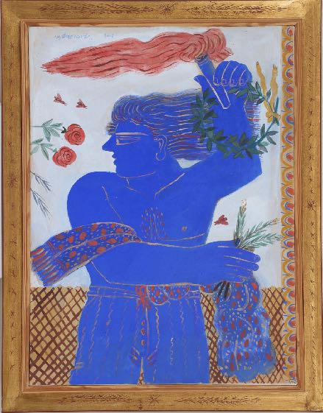
A. Fassianos, Olympic Flame ( cat.n. 62)

The works of Christoforos Savvas found new owners and will enhance a new collection. His Vroullisma was auctioned at 18,034 euros, while the Meeting was at 3,606 euros. The collectors showed an expected interest in the works of Alekos Fasianos. His Red Birds (estimated 10,000 euros) reached 15,629 euros, the same price was reached after 8 bids by Young Man in Plaid Shirt (estimated 7,500 euros), while his Olympic Flame more than doubled its original estimate of 7,500 to 16,832 euros after 8 bids. Collector interest was expressed for many other artworks through collectors' bids, among others, the Portrait of N. Schiavoni by Aristides Oikonomou at 3,606 euros, the Farmers of Geralis at 6,612, the Untitled of Andreas Charalambisis at 16,832 euros. The small Composition of Pantaleon reached 1,923 euros, the Landscape of Ladomatos 3,967 euros, the Butterfly of Geros at 4,208 euros, while the Effervescence of Tsigos was sold for 4,809 euros.

There was also a competition among collectors for the work of Germenis Woman with a Pitcher. The painting doubled its initial value of 650 euros to 1,442 euros after 11 bids. Argostoli, by the same artist, reached 1,923 euros, while Mykonos by Kalligiannis was purchased at 2,284 euros. A duel was also held for the dynamic early charcoals on paper by Nikos Kourousiis, exceeding three times their price (estimated 300 euros), reaching 901 and 1082 euros, respectively. The public honoured with interest the works of Andreas Tomblin, which reached 1082, 841 and 961 euros, of Glyn Hughes at 2,645 euros, and of Erotokritos Mermaid and Angel at 4,208 euros. The auction of the painting entitled Motherhood by Xanthos Chatzisotiriou made a sensation, which after 15 bids from 1,500 euros went up to 5,290 euros.

The public also expressed interest in the three-dimensional works, acquiring Pavlos Dionysopoulos' Potiri at 1,202 euros and the works Couple and Erotic by Moralis, which were auctioned at 2,645 and 4,809 euros, respectively.

The overall results of the 32nd Psatharis Auction are posted on the website of the House
https://www.psatharis-auctions.com.cy/auction1.htm

Xanthos Chatzisotiriou, Motherhood (cat.n. 135)

