PSATHARIS AUCTION HOUSE

The 31ST AUCTION

PRESS RELEASE – AUCTION RESULTS

Michael Kashalos achieves best price
Alekos Fasianos sets new price point

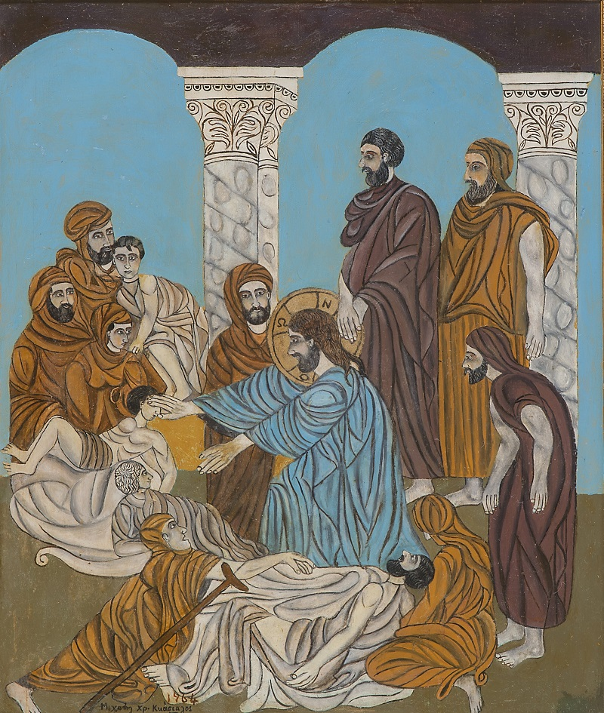
Christ heals the lame, the blind, the leper, and the paralytic
NICOSIA – The 31st Psatharis Auction realised a combined total of €347.000 achieving 71 percent per lot and 99 percent per value, riding out the threat posed to the art market by Russia’s invasion of Ukraine. The auction, held on the 8th of June, brought to the market 133 lots showcasing 19th and 20th century Greek and Cypriot Art alongside contemporary names. A total of 94 lots were sold landing the House a successful evening.
Among the safer bets, Michael Kashalos’s Christ heals the lame, the blind, the leper, and the paralytic achieved best price €31.819 (Estimate: €27.000). Carrying elements of the transcendental qualities of Byzantine Art and the subtlety of Franco-Flemish miniatures the painting reveals the artist’s ability to also morph these artistic styles into his own.
Zachlorou by Yiannis Spyropoulos and Abstract by Christoforos Savva sold at high pre-sale estimates for €19.236 and €18.034 respectively.
New price points
The market for artists with enduring market success may have tested and appeared secured but it was many other artists that experienced competition from the bidders.
Seven bidders competed for Love with Sheaves by Greek painter Alekos Fasianos, which more than doubled its estimate (€12.000) selling for €26.450. Robust figures, exuberant colour and archetypal signs are a motif which fascinated Fasianos. Young man with Sheaves (pastel on paper) also exceeded expectations when it sold for €4.688 more than doubling its estimate (€2.000).
Ioannis Kissonergis also stood out with three paintings leaping past their estimate: Untitled sold for €14.427 (estimate: €6.000). The painting is a beautiful dialogue between figure and backdrop. Reverse side watercolour Kyrenia and Beggar sold for €14.427 (estimate: €8.000). Platanistasa sold for €9.618 (estimate: € 7.000).

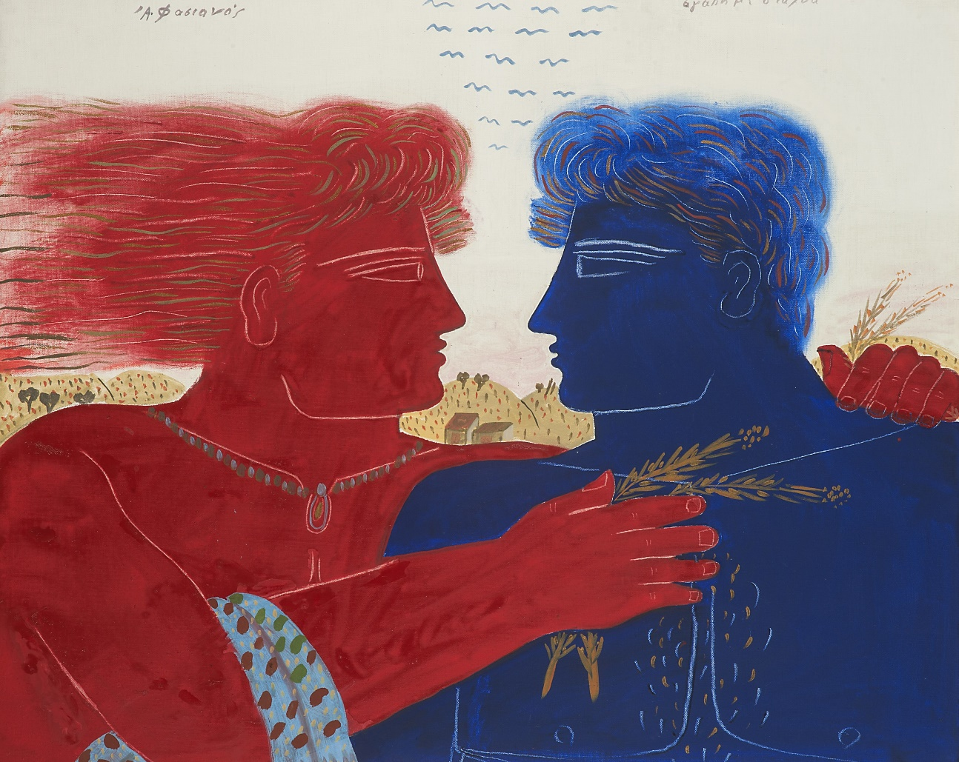
Love with Sheaves, Fasianos

The houses of the priests lay in ruins by Telemachos Kanthos sold for €10.820 doubling its estimate (€5.000). Figure by Andreas Charalambides sold for €7.213 breezing past its estimate (€5.000) and Figures by Andreas Karayan doubled its estimate (€2.500) selling for €5.169. Landscape by Stass Paraskos doubled its estimate (€2.500) achieving a price of €4.568. In the Coffee shop by Lefteris Economou exceeded expectations selling for €5.650 (estimate: €2.500).
Collectors also competed for the rare map of Cyprus by Moullart-Sanson (ed.), L'Isle (et autrefois Royaume) de Chypre, which sold for €3.300 more than doubling its estimate (estimate: €1.500)
Additional highlights

Table by Theodoros Manolidis (sold for €8.055), Card players by Pavlos Samios (sold for €5.650), Without Title (Abstract Geometric Series) by Katy Stefanides (sold for €3.847), Amiantos by Nikos Nikolaides (sold for €3.606), Figures by Constantinos Giannikouris (sold for €4.208), Stones and Water (series) by Andreas Ladommatos (sold for €6.011), Throne by Andreas Chrysochos (sold for €4.568), Untitled by Dimitris Yeros (sold for €5.290), Transformation (series) by Nikos Kouroussis (sold for €3.606), Untitled by Andreas Nicolaou (sold for €3.605), Untitled by Eleni Nikodemou (sold for €3 366), Untitled by John Christoforou (sold for €4.328), Consolation by Xanthos Hadjisoteriou (sold for €3.967) Untitled by Thanos Tsingos (sold for €3.606) Figure by George Mavroides (sold for €3.005), Untitled by Giorgos Erotokritos (sold for €4.809) and others.

Prices of the sold lots include commission and VAT.
The results of the 31st Psatharis Auction can be viewed at https://www.psatharis-auctions.com.cy/results_31.htm

