PSATHARIS AUCTION HOUSE

RESULTS – The 27th AUCTION

The 27th auction of the Psatharis Auction House was marked by new record highs for paintings by Christoforos Savva and Michael Kashalos
Fierce bidding for a painting by Alkis Keramidas

PRESS RELEASE – AUCTION RESULTS

Chistoforos Savva Marseille with Port

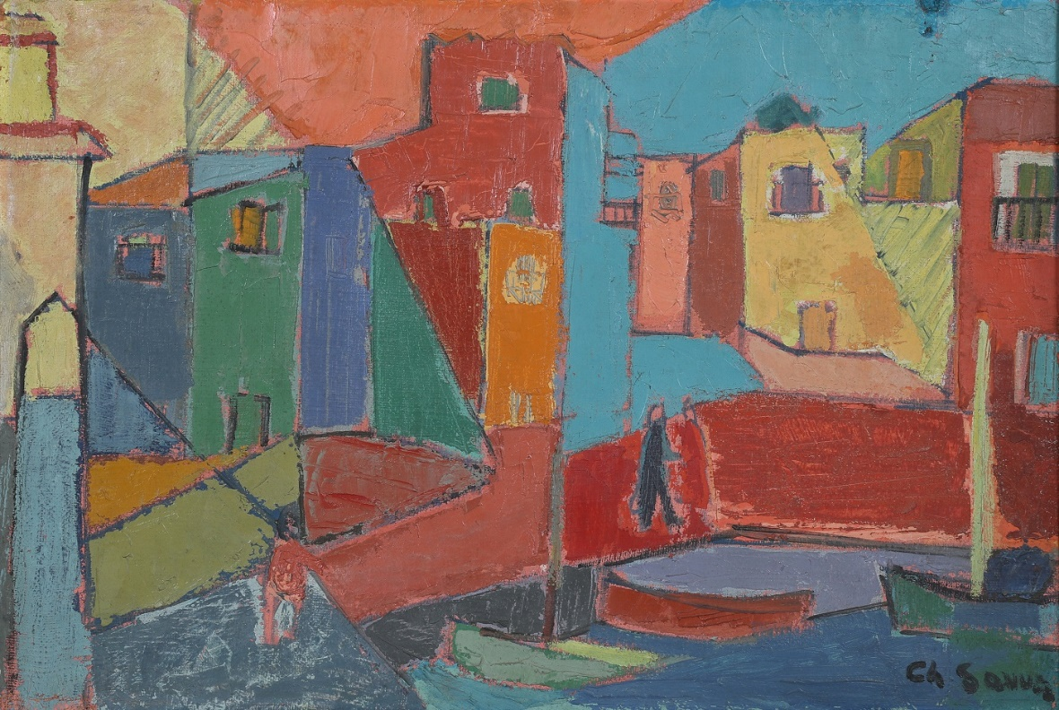
The 27th auction of the Psatharis Auction House took in a total of €256.500. Of the 140 lots offered, the sale saw a sell through rate of 57 percent by lot (80 works sold) and 86 per cent by value.
“New record highs were recorded, and overall the evening sale had great results,” said Nikos Psatharis, founder of the auction house. “It’s important for us to keep our growth story going.” He noted an over €30,000 increase in total sales on the evening of the 4th of December compared with the €227.391 result of the spring auction this year.
The highest-priced lot of the evening was Christoforos Savva’s Marseille with Port, a brilliant abstract with large colour planes permeating the painterly surface with motion. The painting by the 20th century Cypriot modernist sold for €39.533 far surpassing the estimate of €19.000 and setting a new auction selling price record for the artist.
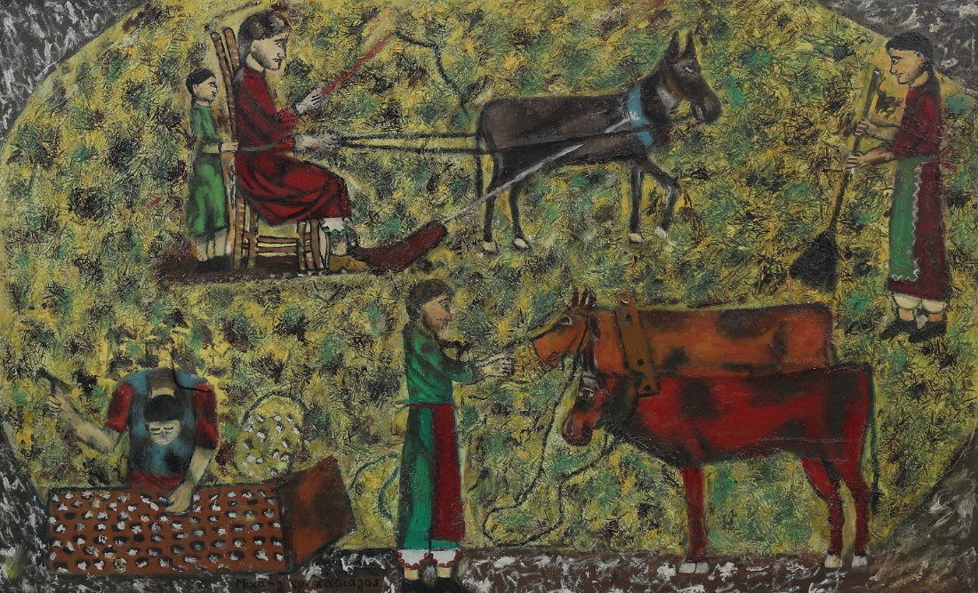
Also a record was the €36.176 price achieved for Michael Kashalos’s Threshing, which was sold against an estimate of €18.000. The leading 20th century Cypriot naïve painter is widely known for projecting rural life narrations onto flat surfaces.
Tense bidding
The Psatharis Auction House has long been the destination for traditional Cypriot art fare, but in recent years it has been leaping into Greek art territory with impressive results. This was reflected on the evening of the 4th of December when Shepherdess, a painting by Greek artist Alkis Keramidas was met with robust demand. The auction room came alive as frenzied bidding soared to 45 bids. The hammer came down with the final bid of €17.677 against the estimate of €2.300.
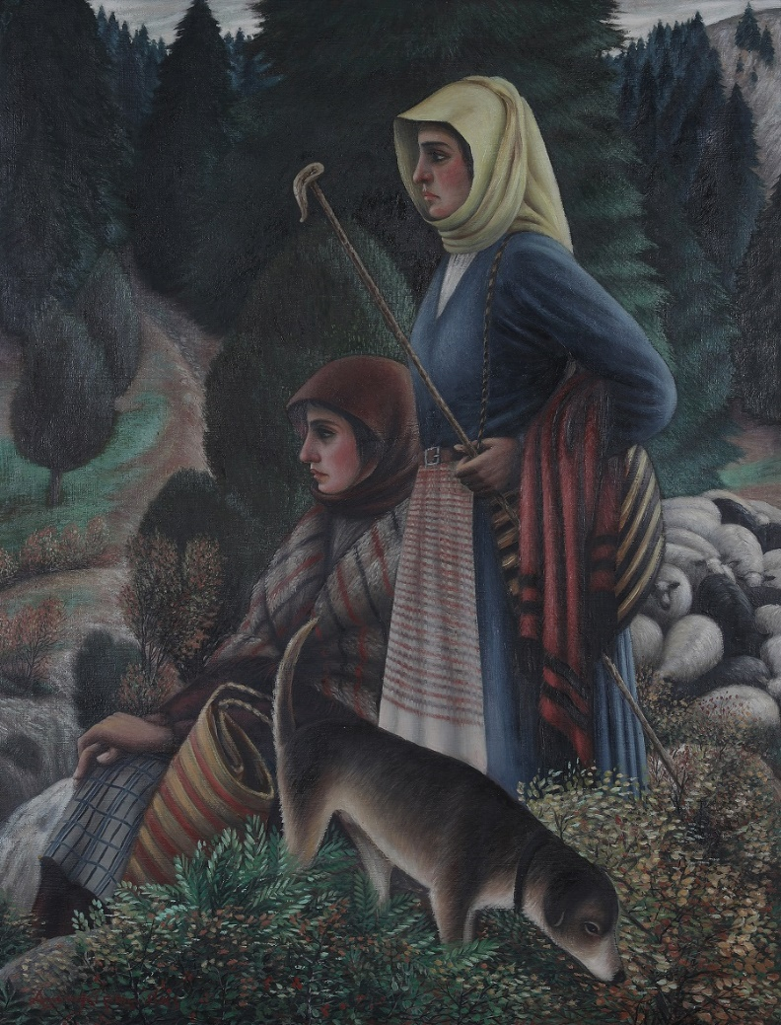
Usually, past auction results provide insight into an artist’s market trajectory. For Fotos Hatzisoteriou paintings prices soared again. After 14 bids, the artist’s painting Figures more than doubled its estimate of €1.400 to €4.006.
Another bright spot of the evening was Angelo’s Yialinas’ The Marka Entry– Corfu which leapt past the predicted price of €1.400 to fetch €4.714. Bidding was heated also for the painting of Apostolos Geralis Girl lights her candle which sold for €5185 as well as for Lefteris Economou’s Windmills which went under the hammer for €3889.
Lower spenders bid against each other for a small painting by Greek Kostas Tsoklis which sold for €1767 and for a painting by Edouardo Sakayan which after 9 bids achieved €2121.
Another interesting highlight of the evening was fierce bidding for an etching by Telemachos Kanthos and an etching by Kostas Averkiou achieving €1414 each following 12 and 8 bids respectively.
The results of the 27th Psatharis Auction can be viewed at: www.psatharis-auctions.com.cy

